Tutorial 3: Inter-VLAN Routing
- With reference to Figure 3.1, identify the type of inter-VLAN routing and explain the limitation of this inter-VLAN routing.
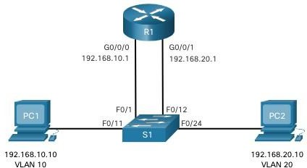

Figure 3.1: Network Topology

- Legacy Inter-VLAN routing
- It does not scale well. This is because it has to occupy one physical interface for each VLAN on the router. Meanwhile, router has limited physical interfaces, it requires additional physical router interface expansion if there is insufficient physical interface to support VLAN.

- A junior network associate had setup router-on-a-stick inter-VLAN configuration as depicted in Figure 3.2, Figure 3.3 and Figure 3.4. The basic requirement is to setup two VLANs which are VLAN 301 and VLAN 303. PCA and PCB are in VLAN 301 whereas PrinterC is in VLAN 303. VLAN 301 is assigned to first subnet and VLAN 303 is assigned to second subnet of 192.168.10.0

Identify SIX (6) configuration errors using the information from Figure 3.2, Figure 3.3 and Figure
3.4 to allow PCA and PCB (both PCs are in VLAN 301) to print using PrinterC (VLAN 303). Document the configuration errors and give correct solutions using Table 3.1 in your answer.
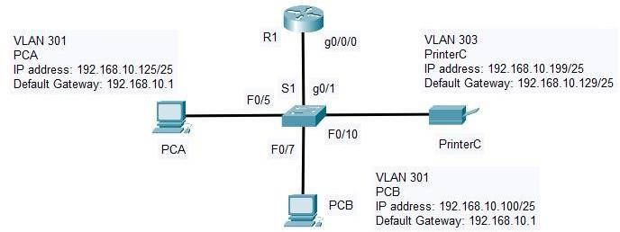

Figure 3.2: A network topology diagram

S1(config)#int g0/1
S1(config-if)#switchport mode access S1(config-if)#exit
Figure 3.3: S1 configurations

R1(config)#int g0/0/0.301
R1(config-subif)#encapsulation dot1Q 301
R1(config-subif)#ip address 192.168.10.1 255.255.255.0 R1(config-subif)#int g0/0/1.303
R1(config-subif)#encapsulation dot1Q 33
R1(config-subif)#ip address 192.168.10.126 255.255.255.128 R1(config-subif)#int g0/0/0
R1(config-if)#shutdown
Figure 3.4: R1 configurations

Item | Configuration Errors | Solutions
1. | PrinterC’s default gateway is wrongly configured. (X) | Reassign the default gateway to 192.168.30.1/25. (X)
2. | PrinterC should use the IP address with different subnet. (X) | Reassign the IP address to 192.168.30.199/25. (X)
3. | S1’s switchport mode is wrongly configured. (/) | Switch the switchport mode to trunk using command “switchport mode trunk” (/)
4. | R1 has applied the configuration on the wrong interface. The interface should be g0/0/0.303 instead of g0/0/1.303. (/) | Apply the configuration on the interface g0/0/0.303 using command “int g0/0/0.303”. (/)
5. | VLAN selected in the statement “encapsulation dot1Q 33” is wrong on R1. (/) | Apply the encapsulation on VLAN 303 using command “encapsulation dot1Q 303”. (/)
6. | The IP address assigned for encapsulation on R1 is wrong.  (Subnet mask wrong) | int g0/0/0.301  encapsulation dot1Q 301  ip address 192.168.10.1 255.255.255.128 (/)  int g0/0/1.303  encapsulation dot1Q 303  ip address 192.168.30.126 255.255.255.128 (X)  (should be  ip address 192.168.10.129  255.255.255.128)
 | S1 port g0/1  - configure S1 port g0/1 as trunk | int g0/1  switchport mode trunk
 | R1 interface g0/0/0 status is shutted down. | int g0/0/0  no shutdown
Table 3.1: Documentation Table

- Identify the type of inter-VLAN routing based on Figure 3.5. Explain the steps to configure this type of inter-VLAN routing.

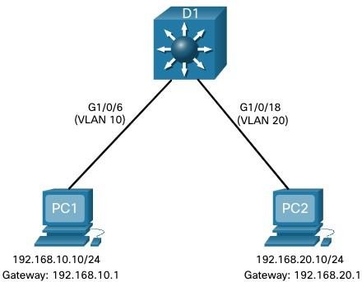

Figure 3.5: A network topology diagram

- Layer 3 switch using switched virtual interfaces (SVIs)
- Step 1: Create the VLAN 10 and 20.
- Step 2: Create the SVI VLAN interfaces. The IP address configured will serve as the default gateway for hosts in the respective VLAN.
- Step 3: Configure access ports. Assign the appropriate port to the required VLAN.
- Step 4: Enable IP routing. Issue the ip routing global configuration command (command: ip routing) to allow traffic to be exchanged between VLAN 10 and 20. The command must be configured to enable inter-VLAN routing on Layer 3 switch for IPv4.

- ABC College’s campus network topology is shown in Figure 3.6. The network VLAN information is shown in Table 3.2. PC1 belongs to the Student VLAN and PC2 belongs to the Faculty VLAN. An inter-VLAN routing is proposed to be configured to allow all the hosts from the two VLANs to communicate with each other.

Suggest configurations for ALL the intermediary devices based on the information from Figure
3.6 and Table 3.2. Document your configuration for every intermediary device using Table 3.3.

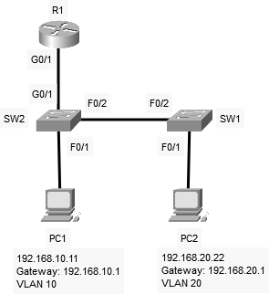

Figure 3.6: Campus network topology

VLAN ID | VLAN Name | Network Address
VLAN 10 | Student | 192.168.10.0/24
VLAN 20 | Faculty | 192.168.20.0/24
Table 3.2: VLAN Information

Device | Configuration
R1 | interface g0/1  no shutdown  interface g0/1.10  encapsulation dot1q 10  ip address 192.168.10.1 255.255.255.0  interface g0/1.20  encapsulation dot1q 20  ip address 192.168.20.1 255.255.255.0
SW1 | vlan 10  name Student  vlan 20  name Faculty  interface f0/2  switchport mode trunk  switchport trunk allowed vlan 10, 20  no shut  interface f0/1  switchport mode access  switchport access vlan 20  no shut
SW2 | vlan 10  name Student  vlan 20  name Faculty  interface f0/2  switchport mode trunk  switchport trunk allowed vlan 10, 20  no shut  interface f0/1  switchport mode access  switchport access vlan 10, 20  no shut  interface g0/1  switchport mode trunk  switchport trunk allowed vlan 10, 20  no shut
PC1 | ipconfig /ip 192.168.10.11 255.255.255.0 192.168.10.1 (no need, not intermediary device)
PC2 | ipconfig /ip 192.168.20.22 255.255.255.0 192.168.20.1 (no need, not intermediary device)
Table 3.3: Documentation table

- Ali was assigned to setup a router-on-a-stick inter-VLAN routing configuration as shown in Figure
3.7. He has done some configuration settings as depicted in Figure 3.8 and Figure 3.9. All the interfaces on the switches and the router are functioning after he issued “no shutdown” command. He seeks your advice as the PCs are unable to communicate with each other.

Examine FIVE (5) configuration errors based on the information from Figure 3.7, Figure 3.8 and Figure 3.9. Document the configuration errors and give correct solutions with justifications using Table 3.4 in your answer.

Note:
- The VLAN database has been created.
- VLAN 99 is designated as the native VLAN as well as the management VLAN.
- The allowed VLANs to go through the trunk links are VLAN 11, 22 and 99.
- The default gateway for hosts in VLAN 11 is 192.168.11.1/24.
- The default gateway for hosts in VLAN 22 is 192.168.22.1/24

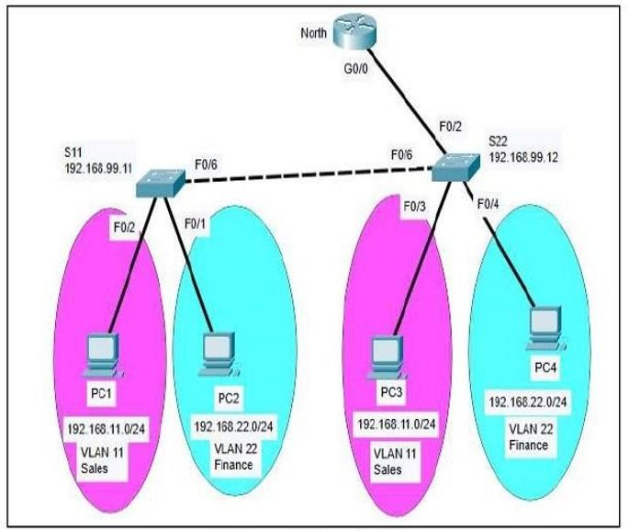
Figure 3.7: A network topology diagram

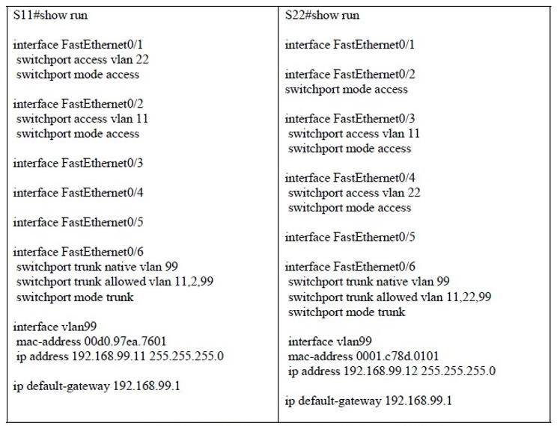
Figure 3.8: Partial output of “show run” in switches S11 and S22

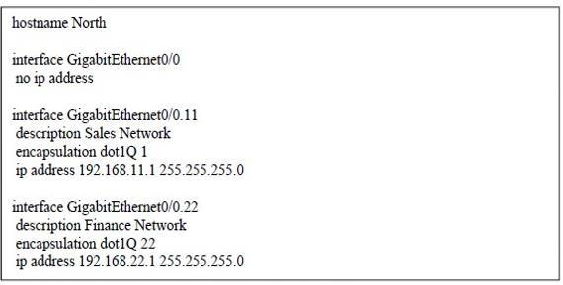
Figure 3.9: Partial output of “show run” in router North

Item | Configuration Errors | Configuration Solutions | Justification
1. | The VLAN allowed for trunk in interface FastEthernet0/6 is wrongly configured. | Only VLAN 11, 22 and 99 should be allowed for trunk.  The command is “switchport trunk allowed vlan 11, 22, 99” | VLAN 2 is unused based on the diagram but VLAN 22 is used as Sales VLAN.
2. | The switchport mode for FastEthernet0/2 in switch S22 is wrongly configured. | The switchport mode for the interface should be set as the trunk using command “switchport mode trunk”. | The trunk can help the switch to support router-on-the -stick inter-VLAN routing.
3. | There is no IP address assigned to the router North GigabitEthernet0/0 interface. | The IP address of 192.168.99.1 with subnet mask 255.255.255.0 should be assigned to the router North GigabitEthernet0/0 interface. | There must be an IP address assigned to router North GigabitEthernet0/0 interface for being the default gateway of switches S11 and S22.
4. | The encapsulation VLAN is wrongly configured on GigabitEthernet0/0.11. | The VLAN used should be 11 instead of 1. The command is “encapsulation dot1Q 11”. | Based on the diagram, the router should set the encapsulation to VLAN 11 instead of VLAN 1 as only VLAN 11, 22 and 99 are used.
5. | Encapsulation for native VLAN 99 is missing in router North. | On the GigabitEthernet0/0 interface in router North, a command should be added: “encapsulation dot1Q 99 native”. | VLAN 99 is used as a native VLAN for router North and all switches in the diagram.
Table 3.4: Documentation Table

